The Dangers of Using PowerPoint as a Communication Tool

*…and How Best to Use it if you Must*

A presentation by Jean Lunde

July 18, 2019

Visual Aids

This document contains figures 1—5 which are referenced in the oral presentation.

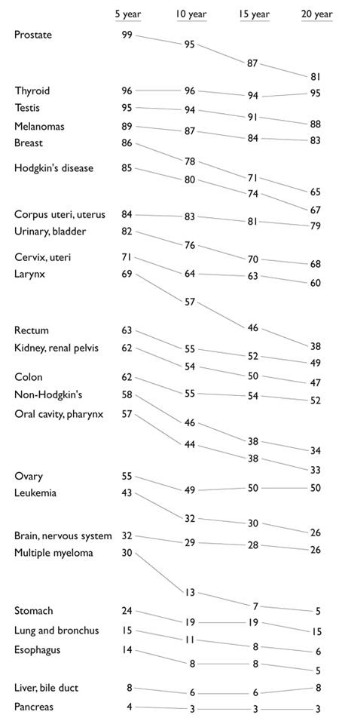

Fig. 2. An elegantly simple chart: It contains the *same* data as that of the six charts on the left. Note how the data has been ordered, and how the viewer can comprehend at a glance the relative survival rates over five-year periods. Cancer survival chart revision by Edward Tufte. *Beautiful Evidence*, p. 176.

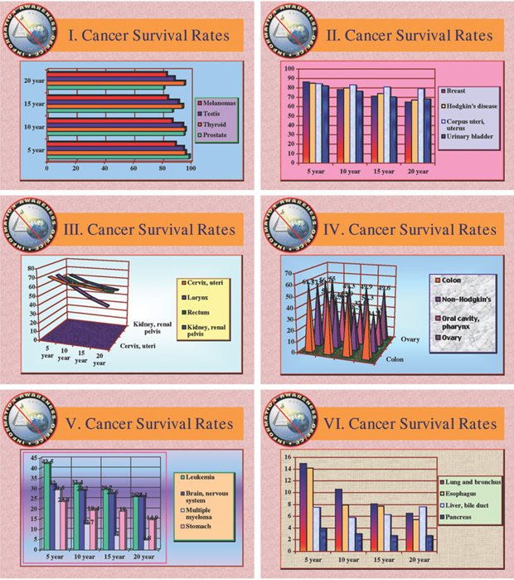

Fig. 1. An example of extreme “chartjunk:” The data in these charts becomes incomprehensible as format takes precedence over content. Survival Rates chart from the Information Awareness Office of Defense Advanced Research Projects Agency (DARPA), 2002.

.

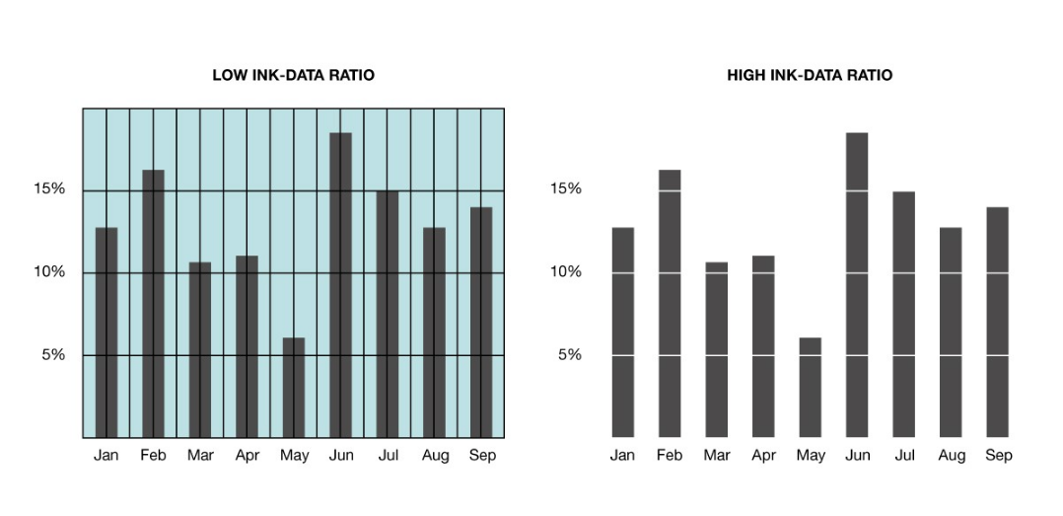

**Fig. 3. Removing extraneous elements of a chart to remove distractions: The background color and grid have been removed from the chart on the left, resulting in the chart on the right which contains no excess “ink;” it has a high ink-data ratio. (Data ÷ ink = ink-data ratio.)** [**https://www.winwire.com/data-visualization/**](https://www.winwire.com/data-visualization/)**.**

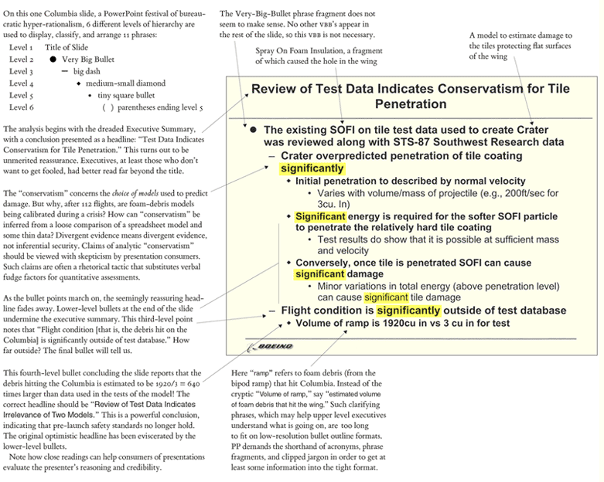

**Fig. 4. Edward Tufte’s analysis of a Boeing PowerPoint slide for the Columbia Accident Investigation Board. Source: Edward Tufte, “PowerPoint Does Rocket Science: Assessing the Quality and Credibility of Technical Reports,” *Beautiful Evidence* (Cheshire, CT: Graphics Press LLC, 2006) p. 164.** [**https://www.edwardtufte.com/bboard/q-and-a-fetch-msg?msg_id=0001yB&topic_id=1&topic=Ask+E%2eT%2e**](https://www.edwardtufte.com/bboard/q-and-a-fetch-msg?msg_id=0001yB&topic_id=1&topic=Ask+E.T.)**.**

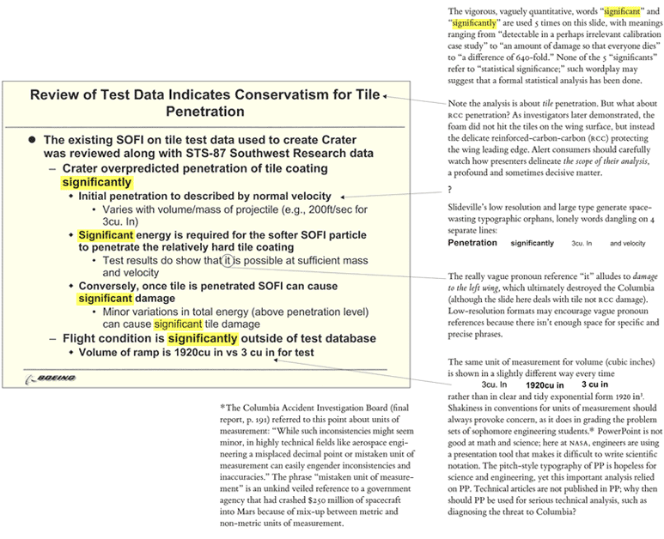

**Fig. 5. Edward Tufte’s analysis of a Boeing PowerPoint slide for the Columbia Accident Investigation Board. Source: Edward Tufte, “PowerPoint Does Rocket Science: Assessing the Quality and Credibility of Technical Reports,” *Beautiful Evidence* (Cheshire, CT: Graphics Press LLC, 2006) p. 165.** [**https://www.edwardtufte.com/bboard/q-and-a-fetch-msg?msg_id=0001yB&topic_id=1&topic=Ask+E%2eT%2e**](https://www.edwardtufte.com/bboard/q-and-a-fetch-msg?msg_id=0001yB&topic_id=1&topic=Ask+E.T.)**.**